

ACKNOWLEDGEMENT



We are very thankful to all, who have helped us in preparing this project. We are very much happy to present this “Project Report “Before you, expecting that you will Acknowledgement it. It is a great pleasure for that we have a unique opportunity of the project works and now we have an opportunity to express our view.

As a part of our academic study, as the student of 5th semester of BCA we are required to undergone training for software project for in order to obtain practical knowledge and our view regarding the same. At first, we would like to express our special & humble thanks and gratitude to the Director of our College Mr. Gautam Kansagara who has provided us such a great co-operative and progressive environment. Secondly, at this moment, we would like to express our deepest sense of gratitude to our professor as project guides Asst. Prof. Sejal Jadav who have contributed their precious time for the purpose of giving us the correct information with special and guidance throughout our project work. We would like to express our special thanks to Principle of the “CCSIT College” to have given their precious time for us and provide all the possible information for our practical study. We are also thankful to our classmate and others who helped us directly or indirectly in solving problem & making our software project more efficient and good working.

**Yours Faithfully,**

Delvadiya Foram D.

ABSTRACT



As a part of my course curriculum BCA in project report, we are assigned practical study as well as the theoretical knowledge in the relate areas for implementing the project of real time applications. We have been preparing grand project report on online Medicine garments order website “PHARMA

CONNECT”.

PHARMA CONNECT is a website designed primarily use for purchasing different Medicine items. This system will allow to choose medicine related from different category and buy the variety of the products. The product-delivery should be timely, convenient and comprehensive. Our app has easy features.

**CHAPTER 1 PROJECT PROFILE**



| **Sr** | **Title** | **Detail** | | | | |
| --- | --- | --- | --- | --- | --- | --- |
| 1. | Group No. | 21 | | | | |
| 2. | Project Title: | PharmaConnect | | | | |
| 3. | Project Type: | Online Shopping | | | | |
| 4. | Front End Tool: | WordPress | | | | |
| 5. | Back End Tool: | My SQL | | | | |
| 6. | Group Member: | 01 | | | | |
| 7. | Member Name: | No. | Roll No. | Name | | |
| 1. | 8 | Delvadiya Foram D. | | |
| 8. | H/W Requirement | H/W | Server Side | Client Side | | |
| Processor | Dual core | Dual core | | |
| RAM | 2 GB | 2 GB | | |
| Hard Disk | 18 GB | 18 GB | | |
| 9. | S/W Requirement | Server Side | | | | |
| Front End | Wordpress | | | |
| Back End | MySQL | | | |
| OS | Windows 8.1 | | | |
| Web Server | XAMPP | | | |
| Client Side | | | | |
| OS | Microsoft Windows 8.1 | | | |
| Browser | Google Chrome | | | |
| 10. | Other | No. | S/W | | | |
| 1. | XAMPP | | | |
| 2. | Dreamweaver | | | |
| 3. | Microsoft Word | | | |
| 5. | Paint | | | |
| 6. | Google Chrome | | | |
| 7. | Microsoft Powerpoint 2013 | | | |
| 11. | Functionality | No. | Admin | | | User |
| 1. | Manage category (CRUD) | | | User Can Login |
| 2. | Manage Product (CRUD) | | | Select Category |
| 3. | View User & Delete User | | | Select Category Wise  Item |
| 4. | Manage Feedback (View,  Delete) | | | View Item Detail |
| 5. | Print Bill | | | Select Quantity |
| 6. | Manage Order  (Display, Delete) | | | Add to Cart |
|  |  | 7. |  | | | Process To checkout |
|  |  | 8. |  | | | View Bill |
|  |  | 10. |  | | | Give Feedback |
| 12. | Submitted By |  | | |  | |

**CHAPTER 2 PROBLEM DETAIL**



### DEFINITION OF SYSTEM

* + - “ PharmaConnect ” is windows based application .It is best for user for getting A different type of Medical Items like Homeopathic , Ayurvadic etc .which is available in our application*.*
    - This Web Application is made using software like Wordpress, SQLLite, etc.

### PURPOSE

* + - We are very confident that this software would be very much useful to the people.
    - We are also typing to different from other trust at this level.
    - We are here by declaring that is an own work with grent help of all friend’s of It and Management.

### OBJECTIVE

* + - **For User:-**
      * User must have a Register/Login
      * View Category
      * View Item
      * Order Item
      * FeedBack
    - **For Admin:-**
      * Login
      * Manage Category
      * Manage Product
      * View Feedback
      * View Billing Detail
      * View All User Info…

### ABOUT PRESENT SYSTEM

* + - It is Manually Working.
    - In present time People use books for reference for mattress.

### PROBLEM IN CURRENT SYSTEM

* + - We can analysis manage about PharmaConnect, we can face many problem are as bellow……
    - It is complete manual system.
    - Due to manual process, it requires more time for completion of any time work.
    - In this system availability of Medical items category any status is too checked manually.
    - Immediate response to the queries is difficult and time consuming.
    - Manual system is costly and it’s difficult to maintain.
    - It’s system required more men power needed and it’s show of the particular place.

### PROPOSED SYSTEM

* + - New System is required because of some advantages of new system are as bellow.
    - It helps to do billing very easily.
    - Account maintenance also becomes easier.
    - New system required less time for completion of any work.
    - The software is provided with the facilities to find out the favorite food of the customer.
    - New system work smoothly and very fast.
    - The seasonal Purchase Items or customers to add or modify and delete their feedback and suggestions.
    - It eliminates the drawbacks of existing system and also includes some more features.

# CHAPTER 3 FUNCTIONALITY OF PROJECT



🡺 User can View Category of Medical Products.

🡺 User can Select Category and view all Medical of particular Category.

🡺 User can select any Medical item and view details of specific Products.

🡺 User can add Medical Products to Favorite and view detail of favorite Medical Products.

🡺 User can add products to their cart and proceed to checkout.

🡺 Users can Share Medical Items to other using Facebook, Instagram etc.

🡺 User can give Feedback.

🡺 Admin can manage product categories and inventory.

🡺 Admin can process and print invoices.

🡺 Admin can receive feedback.

# CHAPTER 4 REQUIREMENT ANALYSIS



### REQUIREMENT ANALYSIS METHODS

#### Fact Finding Technique:-

* + - * The function of the existing system analyst needs to collect data related to the existing system.
      * The data related to organization, staff, document, format used in the input & output process collected.
      * This information is obtained through various fact- finding tools i.e. Review, questionnaires, observations & interviews.
      * Depending on these requirements the system has to be developed.

#### 4.2.2 Interview:-

* Analyst can use interviews to collect information about the current system from the potential users. Here, the analysts discover the areas of misunderstanding, unrealistic exception and descriptions of activities and problems along with resistance to the new proposed system.
* **Two types of interviews:** -

1. **Unstructured**
2. **Structured.**

There are **three** reasons for interviewing a user:

1. The study /identify working of the system.
2. To discover relationship between information system and user.

3) To study the drawback of current system.

#### Questionnaire:-

* + - * These are the questions to which individuals respond.
      * Information? “***Questionnaires are special purpose documents that allow the analyst to collect information & opinion from respondent by using Questionnaire". `***
      * It is possible to a collect response or opinion from a user.
      * To prepare the Questionnaire the analyst has to work hard.
        + What is exact process for this App?
        + How much comfortable you are with current system?
        + What are the disadvantages of the current system?
        + What are the advantages of the current system?
        + How much time do you have to spare for evaluation of

**Advantage of Questionnaire:**

* + - * + It is economical and requires less skills to administer.
        + A questionnaire can be administered to large number of individuals simultaneously
        + Questionnaires ensure uniformity of questions
        + In a questionnaire respondent give opinion without fear
        + Respondents have time to think the questions over and do calculations to provide more accurate data

**Two types of questionnaires:-**

♣ **Open ended: -**descriptive answer of a question.

♣ **Close ended: -**choice or logical type of answer.

#### Record Review: -

* + - * It is the process of Reviving organization’s document. While investigating, analyst should study of the document of an organization.
      * These document shows be update time –to-time.
      * And even documents should be exact & represent the actual information about the system.
      * Basic record like the reports, regulations etc. can be used for better understanding the system.

#### After that analyst comes on various conclusions.

 No of Department working within the organization.

 No of Categories that will be included in proposed system.  Data flow of current system.

 Drawback of current system.  Limitation of proposed system

### SYSTEM REQUIREMENTS

#### User Characteristics:-

This Application deals with two types of user. In which all the users have different kind of characteristic and have different roles.

1. Admin
2. User
   1. **Admin**
      * Admin can add new features to the Application.
      * Admin is a view feedback of a user.
   2. **User**
      * Users can Choose Category.
      * Users can Choose Home Product and View Detail of Home Product.
      * Users give a feedback.
      1. **Hardware & Software Requirement**

### HARDWARE REQUIREMENT

| **HARDWARE** | **MINIMUM REQUIREMENT** |
| --- | --- |
| **RAM** | 4 GB |
| **Hard Disk** | 250 GB |
| **Processor** | CORE i3 |

* **SOFTWARE REQUIREMENT**

| **SOFTWARE** | **REQUIREMENT** |
| --- | --- |
| **Tools** | XAMPP |
| **Technology** | Wordpress |
| **Documentation Tools** | MS Word 2010 |

#### Tools and Technology

**FRONT-END/BACK-END:**

**Technology used in Project:**

1. XAMPP
2. Apache
3. Mysql
4. PHP
5. Perl 2. Phpmyadmin

3. Wordpress

### XAMPP

#### Introduction of XAMPP

XAMPP is a free and open source cross-platform web server solution stack package, consisting mainly of the Apache HTTP Server, MySQL database, and interpreters for scripts written in the PHP and Perl programming languages.

#### Prerequisites

XAMPP requires only one [zip,](https://en.wikipedia.org/wiki/ZIP_(file_format)) [tar](https://en.wikipedia.org/wiki/Tar_(file_format))[, 7z,](https://en.wikipedia.org/wiki/7z_(file_format)) or [exe](https://en.wikipedia.org/wiki/EXE) file to be downloaded and run, and little or no configuration of the various components that make up the web server is required. The Windows' version of XAMPP requires Microsoft Visual C++ 2017 Redistributable.

## Features

XAMPP is regularly updated to the latest releases of [Apache,](https://en.wikipedia.org/wiki/Apache_HTTP_Server) [MariaDB,](https://en.wikipedia.org/wiki/MariaDB) [PHP](https://en.wikipedia.org/wiki/PHP) and [Perl.](https://en.wikipedia.org/wiki/Perl) It also comes with a number of other modules including [Open SSL,](https://en.wikipedia.org/wiki/OpenSSL) [phpMyAdmin,](https://en.wikipedia.org/wiki/PhpMyAdmin) [MediaWiki](https://en.wikipedia.org/wiki/MediaWiki)[,](https://en.wikipedia.org/wiki/Joomla) [Joomla](https://en.wikipedia.org/wiki/Joomla)[, Word](https://en.wikipedia.org/wiki/WordPress) [Press](https://en.wikipedia.org/wiki/WordPress) and more. Self-contained, multiple instances of XAMPP can exist on a single computer, and any given instance can be copied from one computer to another. XAMPP is offered in both a full and a standard version (Smaller version).

## Usage

Officially, XAMPP's designers intended it for use only as a development tool, to allow website designers and programmers to test their work on their own computers without any access to the Internet. To make this as easy as possible, many important security features are disabled by default. XAMPP has the ability to serve web pages on the [World Wide Web.](https://en.wikipedia.org/wiki/World_Wide_Web) A special tool is provided to [password-protect](https://en.wikipedia.org/wiki/Password) the most important parts of the package.

XAMPP also provides support for creating and manipulating databases in

[MariaDB](https://en.wikipedia.org/wiki/MariaDB) and [SQLite](https://en.wikipedia.org/wiki/SQLite) among others.

Once XAMPP is installed, it is possible to treat a [local host](https://en.wikipedia.org/wiki/Localhost) like a remote host by connecting using an [FTP](https://en.wikipedia.org/wiki/File_Transfer_Protocol) client. Using a program like [FileZilla](https://en.wikipedia.org/wiki/FileZilla) has many advantages when installing a [content](https://en.wikipedia.org/wiki/Content_management_system) [management system](https://en.wikipedia.org/wiki/Content_management_system) (CMS) like [Joomla](https://en.wikipedia.org/wiki/Joomla) or [WordPress.](https://en.wikipedia.org/wiki/WordPress) It is also possible to connect to localhost via FTP with an [HTML editor.](https://en.wikipedia.org/wiki/HTML_editor)

## Etymology

XAMPP’s name is an acronym for:

| Letter | Meaning |
| --- | --- |
| X | as an [ideographic](https://en.wikipedia.org/wiki/Ideogram) letter referring to [cross platform](https://en.wikipedia.org/wiki/Cross-platform) (to be read as “cross”, meaning cross-platform) |
| A | [Apache](https://en.wikipedia.org/wiki/Apache_HTTP_Server) or its expanded form, Apache HTTP Server |
| M | [MariaDB](https://en.wikipedia.org/wiki/MariaDB) (formerly: [MySQL)](https://en.wikipedia.org/wiki/MySQL) |
| P | [PHP](https://en.wikipedia.org/wiki/PHP) |
| P | [PERL](https://en.wikipedia.org/wiki/PERL) |

#### X (Cross platform)

Cross-platform, or multiple-platform, is an attribute conferred to computer software or computing methods and concepts that are implemented and inter-

operate on multiple computer platforms.

#### A (Apache HTTP Server)

Apache is a web server software program notable for playing a key role in the initial growth of the World Wide Web.

According to the Frequently Asked Questions in the Apache project website, the name Apache was chosen out of respect to the Native American tribe Apache an its superior skills in warfare and strategy.

Virtual hosting allows one Apache installation to serve many different websites. For example, one machine with one Apache installation could simultaneously

serve [www.example.com,](http://www.example.com/) [www.example.org,](http://www.example.org/) test47. Test- server.example.edu, etc.

It is a web server that allows you to host your websites or any other content for that matter. Apache is available for UNIX as well as WINDOWS. Some of the most common server-side languages supported by Apache are – PHP, Python and Perl. It is free of charge.

#### M (MySQL/MariaDB)

**Overview**

It is the world’s most popular *open source database*.

MySQL is *written in* [*C*](https://en.wikipedia.org/wiki/C_(programming_language)) *and* [*C++*.](https://en.wikipedia.org/wiki/C%2B%2B) Its SQL parser is written in [yacc,](https://en.wikipedia.org/wiki/Yacc) but it uses a home-brewed [lexical](https://en.wikipedia.org/wiki/Lexical_analysis) [analyzer.](https://en.wikipedia.org/wiki/Lexical_analysis) MySQL works on many [system platforms.](https://en.wikipedia.org/wiki/System_platform)

MySQL was replaced with MariaDB on 2015-10-19 and beginning with XAMPP versions

5.5.30 and 5.6.14 effectively altering the meaning of the acronym.

It is a Relational Database Management System (RDBMS) – data and it’s relationships are stored in the form of tables that can be accessed by the use of MySQL queries in almost any format that the user wants.

* MySQL is a database system used on the web server.
* MySQL is ideal for both small and large applications.
* MySQL is very fast, reliable an easy to use.
* MySQL compiles on a number of platforms.
* MySQL is free to download and use.
* MySQL is developed, distributed, and supported by Oracle Corporation.
* Its name is a combination of ***"My", the name of co-founder*** [***Michael Widenius'***](https://en.wikipedia.org/wiki/Michael_Widenius)***s daughter, and*** [***"SQL"***](https://en.wikipedia.org/wiki/SQL), the abbreviation for [Structured Query Language.](https://en.wikipedia.org/wiki/Structured_Query_Language)

## History

MySQL was created by a Swedish company, [MySQL AB,](https://en.wikipedia.org/wiki/MySQL_AB) founded by [David Axmark,](https://en.wikipedia.org/wiki/David_Axmark) Allan Larsson and [Michael "Monty" Widenius.](https://en.wikipedia.org/wiki/Michael_(Monty)_Widenius)

Original development of MySQL by Widenius and Axmark began in 1994. The first version of MySQL appeared on 23 May 1995.

It was initially created for personal usage from [MYSQL](https://en.wikipedia.org/wiki/MSQL) based on the low-level language [ISAM,](https://en.wikipedia.org/wiki/ISAM) which the creators considered too slow and inflexible.

They created a new [SQL](https://en.wikipedia.org/wiki/Structured_Query_Language) interface, while keeping the same [API](https://en.wikipedia.org/wiki/Application_programming_interface) as MYSQL. By keeping the API consistent with the MYSQL system, many developers were able to use MySQL instead of the (proprietarily licensed) MYSQL antecedent.

### P (PHP)

PHP is *server-side scripting language* designed for web development but also used as a general-purpose programming language.

Originally created by *Rasmus Lerdorf* in *1995*, the reference implementation of PHP is now produced by The PHP Group.

White PHP originally stood for *Personal Home Page*, it now stands for PHP: *Hypertext Preprocessor*.

A server-side programming language which is used to produce dynamic web pages. PHP code can be embedded within HTML. It is also free an platform-independent which means that it can be installed on any operating system. Who uses PHP?

* Facebook
* Yahoo
* Wikipedia
* Wordpress
* Joomla
* 20 million + domain names

#### P (Perl)

Perl is the Swiss Army chainsaw of scripting languages: powerful and adaptable. It was first developed by Larry Wall, a linguist working as a systems administrator for NASA in the late 1980s, as a way to make report processing easier.

#### phpMyAdmin

PhpMyAdmin is a [free and open source](https://en.wikipedia.org/wiki/Free_and_open_source) administration tool for [MySQL](https://en.wikipedia.org/wiki/MySQL) and [MariaDB.](https://en.wikipedia.org/wiki/MariaDB) As a portable [web application](https://en.wikipedia.org/wiki/Web_application) written primarily in [PHP,](https://en.wikipedia.org/wiki/PHP) it has become one of the most popular MySQL administration tools, especially for [web hosting services.](https://en.wikipedia.org/wiki/Web_hosting_service)

#### History

Tobias Ratschiller, then an IT consultant and later founder of the software company Maguma, started to work on a PHP-based web [front-end](https://en.wikipedia.org/wiki/Front-end_and_back-end) to MySQL in 1998, inspired by MySQL- Webadmin. He gave up the project (and [phpAdsNew,](https://en.wikipedia.org/wiki/OpenX_(software)) of which he was also the original author) in 2000 because of lack of time.

By that time, phpMyAdmin had already become one of the most popular PHP applications and MySQL administration tools, with a large community of users and contributors. In order to coordinate the growing number of patches, a group of three developers registered the phpMyAdmin Project at [Source Forge](https://en.wikipedia.org/wiki/SourceForge) and took over the development in 2001.

In July 2015, the main website and the downloads left SourceForge and moved to a content delivery network. At the same time, the releases began to be PGP-signed. Afterwards, issue tracking moved to GitHub and the mailing lists migrated. Before version 4, which uses [Ajax](https://en.wikipedia.org/wiki/Ajax_(programming)) extensively to enhance usability, the software used [HTML frames.](https://en.wikipedia.org/wiki/HTML_frames)

#### Features

Features provided by the program include:

* + - Web interface
    - MySQL and MariaDB database management
    - Import data from [CSV](https://en.wikipedia.org/wiki/Comma-separated_values) and [SQL](https://en.wikipedia.org/wiki/SQL)
    - Export data to various formats: [CSV,](https://en.wikipedia.org/wiki/Comma-separated_values) [SQL,](https://en.wikipedia.org/wiki/SQL) [XML,](https://en.wikipedia.org/wiki/XML) [PDF](https://en.wikipedia.org/wiki/Portable_Document_Format) (via 0the [TCPDF](https://en.wikipedia.org/wiki/TCPDF) library), ISO/IEC 26300 – Open Document Text and Spreadsheet, Word, Excel, [LaTeX](https://en.wikipedia.org/wiki/LaTeX) and others

Administering multiple servers

* + - Creating PDF graphics of the database layout
    - Creating complex queries using query-by-example (QBE)
    - Searching globally in a database or a subset of it
    - Transforming stored data into any format using a set of predefined functions, like displaying [BLOB-](https://en.wikipedia.org/wiki/BLOB)data as image or download-link

♣ Live charts to monitor MySQL server activity like connections, processes, CPU/memory usage, etc.

* + - Working with different operating systems.
    - Make complex SQL queries easier.

#### Wordpress

**What is Content Management System (CMS) ?**

* The Content Management System (CMS) is a software which stores all the data such as text, photos, music, documents, etc. and is made available on your website. It helps in editing, publishing and modifying the content of the website.
* WordPress is an open source Content Management System (CMS), which allows the users to build dynamic websites and blogs. Wordpress is the most popular blogging system on the web and allows updating, customizing and managing the website from its back-end CMS and components.

#### Top Ten Open Source CMS

* WordPress
* Joomla
* Drupal
* Media Wiki
* Plone
* Liferay
* TYPO3
* Moodle
* Dolphin
* Pligg

#### a. Introduction of Wordpress

* WordPress was initially released on 27th May, 2003 by Matt Mullenweg and Mike Little.
* WordPress was open source in October 2009.
* WordPress is an open source Content Management System (CMS), which allows the users to build dynamic websites and blogs. Wordpress is the most popular blogging system on the web and allows updating, customizing and managing the website from its back-end CMS and components.
* There are many plugins and templates available for free .
* Features of Wordpress
* User Management: It allows managing the user information such as changing the role of the users to (subscriber, contributor, author, editor or administrator), create or delete the user, change the password and user information. The main role of the user manager is Authentication.
* Media Management: It is the tool for managing the media files and folder, in which you can easily upload, organize and manage the media files on your website.
* Theme System: It allows modifying the site view and functionality. It includes images, stylesheet, template files and custom pages.
* Extend with Plugins: Several plugins are available which provides custom functions and features according to the users need.
* Search Engine Optimization: It provides several search engine optimization (SEO) tools which makes on-site SEO simple.
* Importers: It allows importing data in the form of posts. It imports custom files, comments, post pages and tags.
* Advantages
* It is an open source platform and available for free.
* CSS files can be modified according to the design as per users need.
* There are many plugins and templates available for free.
* Media files can be uploaded easily and quickly.
* It offers several SEO tools which makes on-site SEO simple.
* Customization is easy according to the user's needs.
* It allows creating different roles for users for website such as admin, author, editor and contributor.
* 3.4 Disadvantages
* Using several plugins can make the website heavy to load and run.
* PHP knowledge is required to make modifications or changes in the WordPress website
* Sometimes software needs to be updated to keep the WordPress up-to-date with the current browsers and mobile devices. Updating WordPress version leads to loss of data, so it a backup copy of the website is required.
* Modifying and formatting the graphic images and tables is difficult.
* Installation of wordpress
* System Requirements for WordPress
* Database − MySQL 5.0 +
* Web Server −
* WAMP (Windows)
* LAMP (Linux)
* XAMPP (Multi-platform)
* MAMP (Macintosh)
* Operating System − Cross-platform
* Browser Support − IE (Internet Explorer 8+), Firefox, Google chrome, Safari, Opera
* Download WordPress
* When you open the link [https://wordpress.org/download/,](https://wordpress.org/download/) you will get to see a screen as the following snapshot −

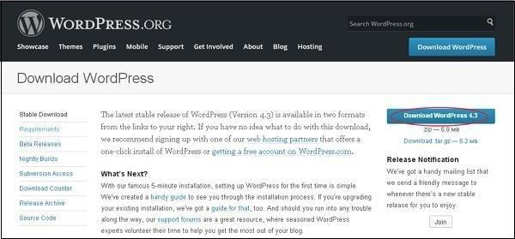

* Create Database
* WordPress requires MySQL database. So create a new empty database with user/password (for example, user as "root" and password as "root" or else you can set as per your convenience).
* Installation of wordpress
* It's very easy to set up WordPress into your system. The following steps describe how to set up WordPress locally on your system.
* Step (1) − Extract the downloaded WordPress folder and upload it into your web server or localhost.
* Step (2) − Open your browser and navigate to your WordPress file path, then you will get the first screen of the WordPress installer as shown in the following screen. In our case, the path is localhost/< Your_wordpress_folder >.

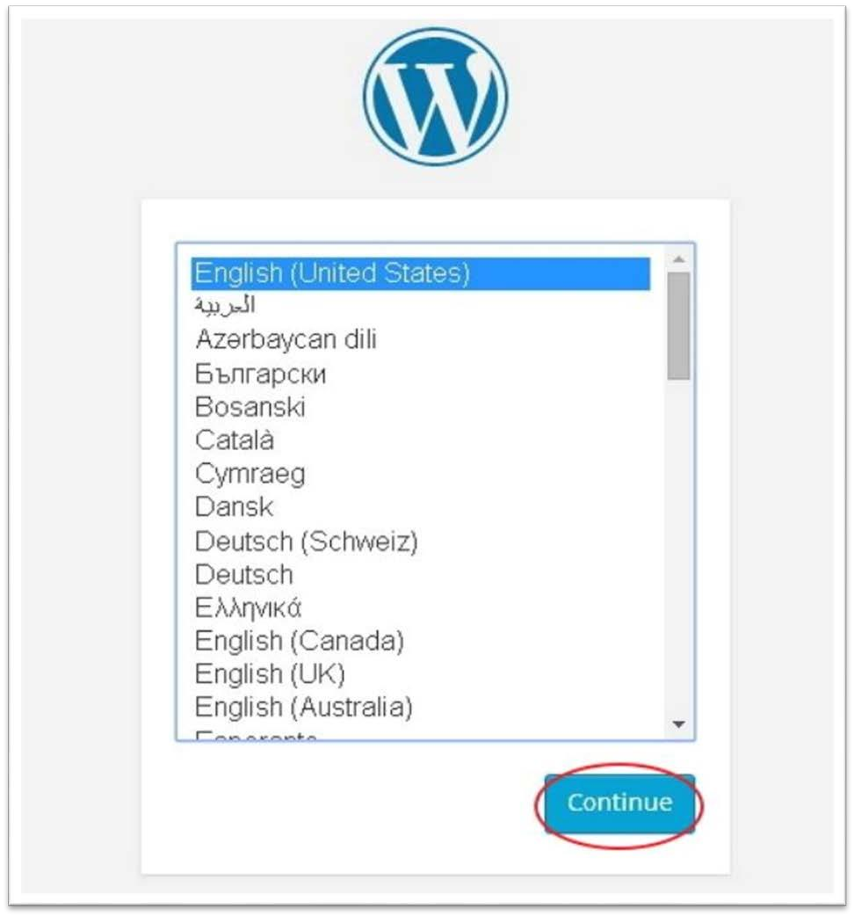

* Select your language for the WordPress and click on Continue.
* Step (3) − In this step, you can view the information needed for the database before proceeding with WordPress installation.

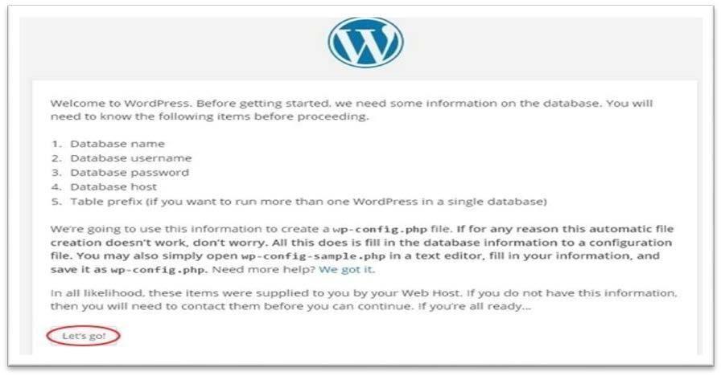

* Click on Let's go!
* Step (4) − Here, you have to enter the information about the MySQL database as described in the following screen.

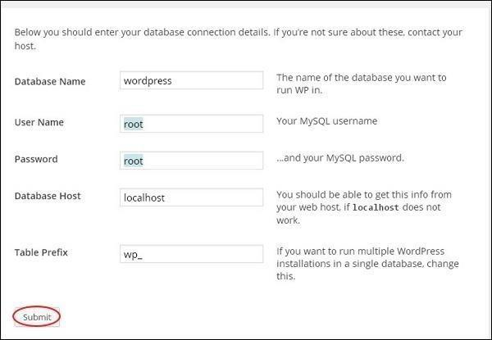

* Database Name − Enter the database name which you have created in MySQL database for WordPress.
* Username − Enter the user name of your MySQL database.
* Password − Enter the password which you had set for MySQL database.
* Database Host − Write the host name, by default it will be localhost.
* Table Prefix − It is used to add prefix in the database tables which helps to run multiple sites on the same database. It takes the default value.
* After filling all information, click on Submit button.
* Step (5) − WordPress checks the database setting and gives you the confirmation screen as shown in the following snapshot.

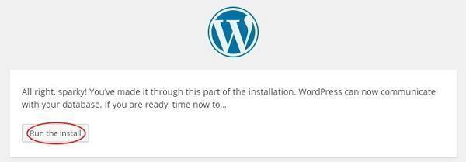

* Click on Run the install
* Step (6) − Enter administrative information.

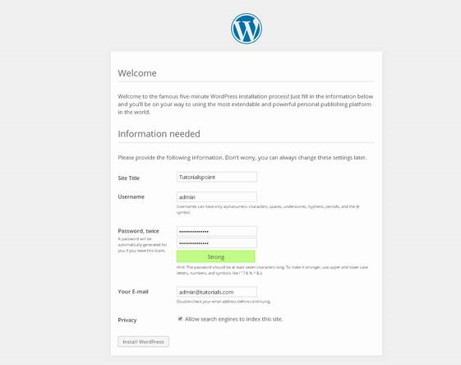

* It contains the following fields −
* Site Title − Enter the name of the site which you are going to create in WordPress.
* Username − Enter the username as per your choice while logging in the WordPress.
* Password twice − Enter password two times to protect your site.
* Your Email − Enter your e-mail address which helps to recover the password or any update.
* Privacy − It allows the search engine to index this site after checking the checkbox.
* After filling all the information, click on the Install WordPressbutton.
* Step (7) − After installation being successful, you will get a screen of the stating success as seen in the following screen.

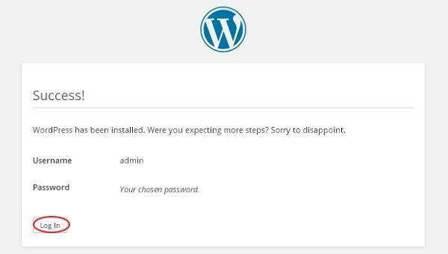

* You can view your username and password detail added in WordPress.
* Click on Log In button • Step (8) − After clicking on login, you will get a WordPress Admin Panel as depicted in the following screen.

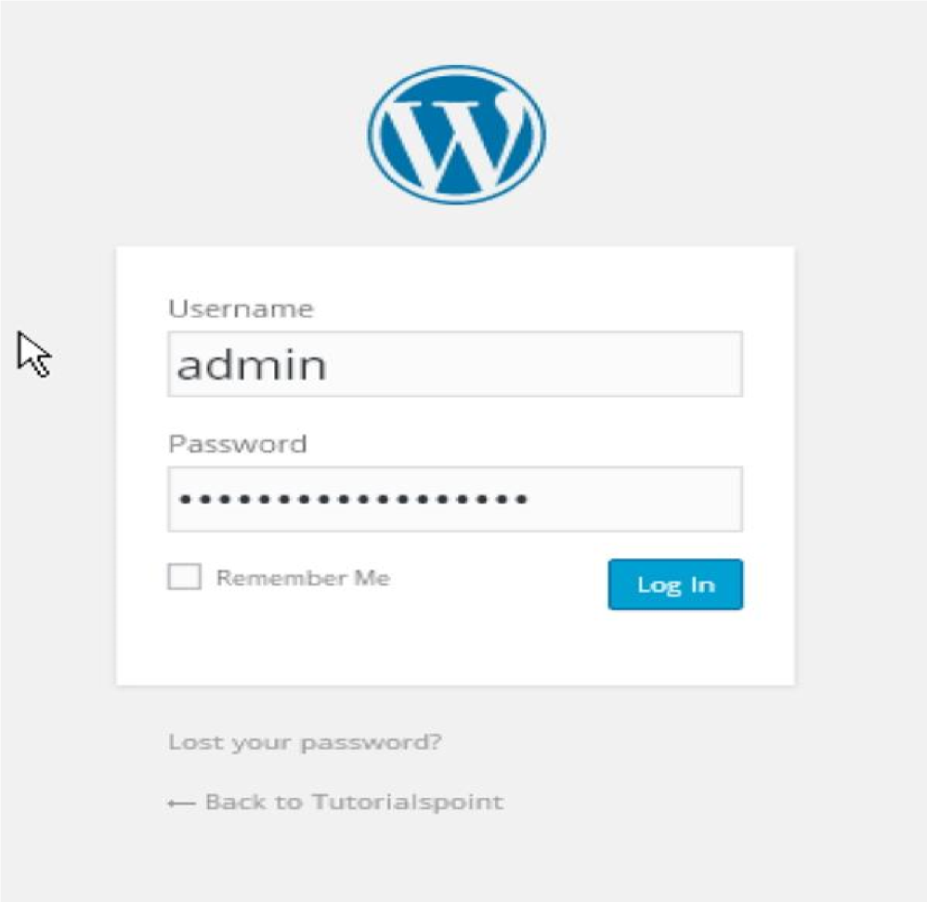

Enter the username and password which you had mentioned during installation as shown in step 6 and click on the Log In button.

#### 3.5 Wordpress Directory & file structure

1. wp-admin
2. wp-content
3. wp-includes
   * index.php
   * license.txt
   * readme.htmlS
   * wp-activate.php
   * wp-blog-header.php
   * wp-comments-post.php
   * wp-config-sample.php
   * wp-cron.php
   * wp-links-opml.php
   * wp-load.php
   * wp-login.php
   * wp-mail.php
   * wp-settings.php
   * wp-signup.php
   * wp-trackback.php
   * xmlrpc.php
   * .htaccess
   * wp-config.php

#### wp-admin

The admin tools are powered by this folder. As it’s name indicates, this deals with the administrator. The main file inside this directory is the admin.php. It enables the connection to the database, displays the WordPress dashboard, and performs any other number of key functions, such as checking if any given user is in fact the admin in question.

#### wp-content

The next folder we are going to see is the wp-content. The Themes and plugins are familiar to every WordPress user. These are stored inside this directory.

## wp-includes

The wp-includes is the final top-level folder and is large in size. As we have seen earlier, the wp-admin includes all the files necessary to power said admin functions, wp-content stores all your themes and plugins, and wp-includes is what enables the site to run.

#### index.php

The index file loads and initializes all your WordPress files when a page is requested by a user.

#### license.txt

This is WordPress license file. The WordPress is a free software and is licensed under the GNU General Public License as published by the Free Software Foundation.

#### readme.html

This core file contains the instructions to the user as its name indicates.

#### wp-activate.php

This contains the following :

do_activate_header()

Function: Adds an action hook specific to this page that fires on wp_head. activate_wp_head

Fires before the Site Activation page is loaded, but on the wp_head action. wpmu_activate_stylesheet()

Function: Loads styles specific to this page. activate_header

Action Hook: Fires before the Site Activation page is loaded.

#### wp-blog-header.php

This folder contains the http headers.

#### xmlrpc.php

WordPress uses an XML-RPC interface. WordPress has its own implementation for WordPress-specific functionality in an API called the WordPress API. This should be used when possible, and your client should use the API variants beginning with the wp prefix.

XML-RPC functionality is turned on by default since WordPress 3.5.

In previous versions of WordPress, XML-RPC was user enabled. To enable, go to Settings > Writing > Remote Publishing and check the box.

#### wp-config.php

It is one of the core WordPress files which contains information about the database, including the name, host (typically localhost), username, and password.

#### Plugin

The plugins are used to add more functionality to the WordPress site. Plugins can offer custom setup to the WordPress installation while the default WordPress installation is designed to be light weight.

#### Themes

The WordPress themes provide the graphical interface to the website. There are many files that work together to achieve this.

* + 1. **Information Gathering**

 **Questionnaires**

| 1) | Your shop website is available? |
| --- | --- |
| Ans. | Yes |
| 2) | What is Maximum price of PharmaConnect? |
| Ans. | 15,000 |
| 3) | What is minimum price of PharmaConnect? |
| Ans. | 10 |
| 4) | Have a discount in your shop? |
| Ans. | deped on item |
| 5) | It the bill format fixed or not? |
| Ans. | Yes , it is fixed |
| 6) | Are you provide for home delivery? |
| Ans. | Yes |
| 7) | How often do you deliver y? |
| Ans. | 2-5 days |
| 8) | How the customer can make a payment? |
| Ans. | Case On Delivery , UPI Payment |
| 9) | Customer can make payments with a credit card? |
| Ans. | Yes |

| 10) | What would you like to create a web based application or windows base application? |
| --- | --- |
| Ans. | Wed based application |
| 11) | What do you attract the customer? |
| Ans. | Advertisement |
| 12) | You have now here else to branch? |
| Ans. | No |
| 13) | Have accepted a big order? |
| Ans. | Yes |

# CHAPTER 5 SYSTEM ANALYSIS



### FEASIBILITY ANALYSIS

* An important outcome of the preliminary investigation is the determination that the system requested is feasible.
* There are three aspects in the feasibility study portion of the preliminary investigation.

#### Operational Feasibility:-

* + - * List of activity that help User
        + Help Line Number
        + User Manual
        + Training

#### Technical Feasibility:-

* + - * First of all in the part of “Technical Feasibility” I stud that whether this software project is technically feasible or not. Means to study that whether the necessary software & Hardware are available.
      * The work for the project be done with current equipment; existing s/w technology is required,

**Windows 10 Professional 64-bit:-**

 **S/W Type :** License Version

 **Price :** Rs.12,779

 **Requirement :-**

**Processor :** Intel Dual Core or Later.

**Memory :** RAM - 1GB (32 bit) / 2GB(64 bit) H HDD -16GB (32 bit) / 20GB (64 bit)

**Microsoft Office 2010 Pro + Visio 2010:-**

 **S/W Type :** License Version

 **Price :** Rs.41,817

 **Requirement :-**

**Processor:**500 MHz

**Memory:** RAM–256MB

**HDD** : 2 GB Free Space Required

**OS** : Windows 7 or Later.

**XAMPP :-**

 **S/W Type :** Open Source

 **Requirement :- Processor:**1 Ghz **Memory:**RAM – 512 MB

**HDD :** 200MB Free Space Required.

**OS:** Windows, Linux, Mac

**Adobe Photoshop 7.0 :-**

 **S/W Type :** License Version  **Price :** Rs.12,5s00

 **Requirement :-**

**Processor:**Intel Pentium or Later.

**Memory:**RAM – 128MB

**HDD** **:** 280MB Free Space Required.

**OS:** Windows Platform

**Google Chrome :-**

 **S/W Type :** Free

 **Requirement :-**

**Processor :** Intel Pentium or Later.

**Memory:** RAM – 1GB

**HDD :**  50MB Free Space Required.

**OS:** Windows, Linux, Mac

**WordPress 4.9.8 :-**

 **S/W Type:**Open Source  **Requirement :-**

**Supported On :**PHP 5.6 or 7.0 +

**Web Server:**Apache, nginx, Microsoft IIS.

**Database :**MySQL, SQL Server, PostgreSQL

#### Economic Feasibility:-

1. **Time Based :** Contrast to the manual system management can generate any report just by single click. In manual system it is too difficult to maintain historical data which become easier in this system. Time consumed to add new records or to view the reports is very less compared to manual system. So this project is feasible at this point of view.
2. **Cost Based :** No special investment need to manage the tool. No specific training is required for employees to use the tool. Investment requires only once at the time of installation. The software used in this project is freeware so the cost of developing the tool is minimal and hence the overall cost.

# CHAPTER 6 SCHEDULING & PLANNING



| **SDLC step** | **Module** | **Estimation Time**  **(in Days)** | **Stating Date** | **Ending Date** | **No. of**  **Days** |
| --- | --- | --- | --- | --- | --- |
| **Analysis** | Information Gathering | 2 | 25/6/2024 | 29/6/2024 | 4 |
| Feasibility study | 3 | 30/6/2024 | 3/7/2024 | 3 |
| **Designing** |  | | | | |
| Data base | 4 | 4/7/2024 | 8/7/2024 | 4 |
| UML | 4 | 8/7/2024 | 11/7/2024 | 4 |
| Activity | 25 | 12/7/2024 | 31/7/2024 | 21 |
| **Plugin** |  | | | | |
| **WooCommerce** | 1 | 12/7/2024 | 13/7/2024 | 1 |
| MC Wishlist WooCommerce | 1 | 14/7/2024 | 15/7/2024 | 1 |
| WooCommerce Smart COD | 1 | 16/7/2024 | 17/7/2024 | 1 |
| Force Authentication Before  Checkout For WooCommerce | 1 | 18/7/2024 | 19/7/2024 | 1 |
| Mystickymenu | 1 | 20/7/2024 | 21/7/2024 | 1 |
| UPI QR Code Payment Gateway | 1 | 22/7/2024 | 23/7/2024 | 1 |
| SMSAlert - WooCommerce | 1 | 24/7/2024 | 25/7/2024 | 1 |
| Simple Chat Button | 1 | 26/7/2024 | 27/7/2024 | 1 |
| PDF Invoices & Packing Slips  for WooCommerce | 1 | 28/7/2024 | 29/7/2024 | 1 |
| Login/Signup Popup | 1 | 30/7/2024 | 31/7/2024 | 1 |
| **Testing** |  | | | | |
| **Unit Testing** | 3 | 1/8/2024 | 3/8/2024 | 3 |
| Category | 3 | 4/8/2024 | 5/8/2024 | 1 |
| Search |
| Detail or view Products | 3 | 6/8/2024 | 10/8/2024 | 4 |
| Wishlist |
| Share |
| Feedback or Review | 1 | 11/8/2024 | 13/8/2024 | 2 |
| About |
| **Integration Testing** | 1 | 14/8/2024 | 14/8/2024 | 1 |
| **Documentation** | Report | 3 | 15/8/2024 | 20/8/2024 | 5 |

**CHAPTER 7 UML DIAGRAMS**



* 1. 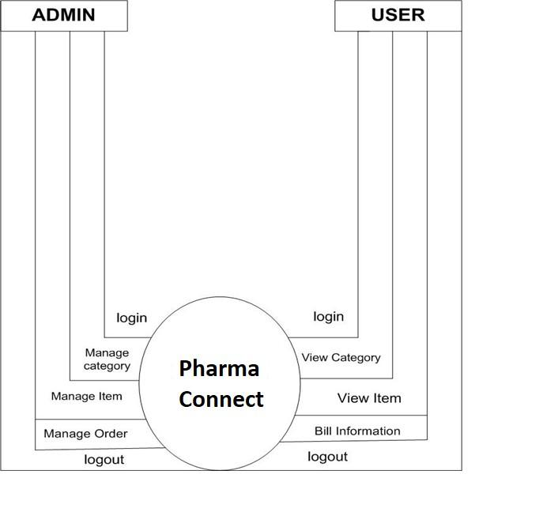**0 Level DFD**

### USE CASE DIAGRAM

* + 1. **Admin**

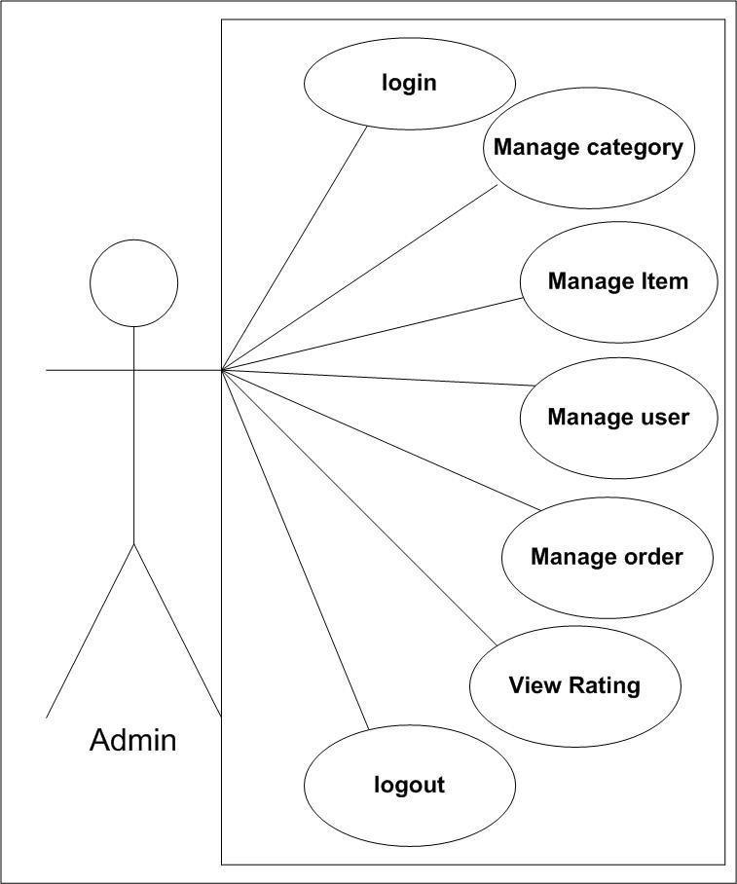

**7.2.2 User**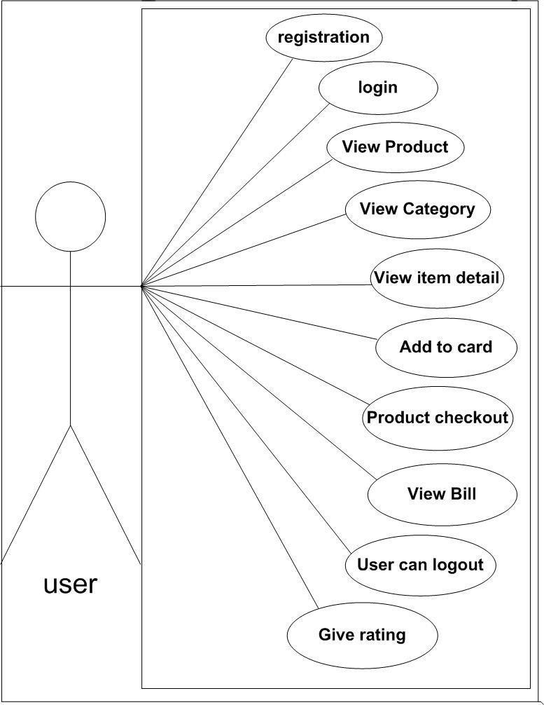

### ACTIVITY DIAGRAM

* + 1. **User**

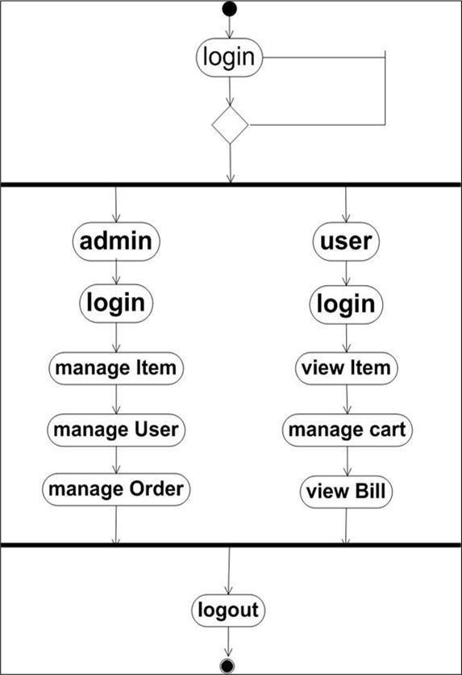

# CHAPTER 8 SYSTEM DESIGN



### 8.1 DATA DICTIONARY

#### WordPress Table

 ***Wp_commentmeta *** ***Wp_comments***

 ***Wp_links *** ***Wp_options***

 ***Wp_postmeta *** ***Wp_post***

 ***Wp_termmeta *** ***Wp_terms***

 ***Wp_term_relationships *** ***Wp_term_texonomy***

 ***Wp_usermeta *** ***Wp_user***

#### wp_user: -

**Name Type**

| 1 | **ID** | **Bigint(20)** |
| --- | --- | --- |
| 2 | **User login** | **Varchar(60)** |
| 3 | **User pass** | **Varchar(255)** |
| 4 | **User_nicename** | **Varchar(50)** |
| 5 | **User email** | **Varchar(100)** |
| 6 | **User_url** | **Varchar(100)** |
| 7 | **User_registered** | **Datetime** |
| 8 | **user_activation_key** | **Varchar(255)** |
| 9 | **User_status** | **Int(11)** |
| 10 | **Display_name** | **Varchar(250)** |

1. **wp_options: -**

**Name Type**

| 1 | **Option_id** | **Bigint(20)** |
| --- | --- | --- |
| 2 | **Option_name** | **Varchar(191)** |
| 3. | **Option_value** | **Longtext** |
| 4 | **Autoload** | **Varchar(20)** |

#### wp_post: -

**Name Type**

| 1 | **ID** | **Bigint(20)** |
| --- | --- | --- |
| 2 | **Post_author** | **Bigint(20)** |
| 3 | **Post_date** | **Datetime** |
| 4 | **Post_date_gmt** | **Datetime** |
| 5 | **Post_content** | **Longtext** |
| 6 | **Post_title** | **Text** |
| 7 | **Post_excerpt** | **Text** |
| 8 | **Post_status** | **Varchar(20)** |
| 9 | **Comment_status** | **Varchar(20)** |
| 10 | **Ping_status** | **Varchar(20)** |
| 11 | **Post_password** | **Varchar(255)** |
| 12 | **Post_name** | **Varchar(200)** |
| 13 | **To_ping** | **Text** |
| 14 | **Pinged** | **Text** |
| 15 | **Post_modified** | **Datetime** |
| 16 | **Post_modified_gmt** | **Datetime** |

| 17 | **Post_content_filtered** | **Longtext** |
| --- | --- | --- |
| 18 | **Post_parent** | **Bigint (10)** |
| 19 | **Guid** | **Varchar(255)** |
| 20 | **Menu_order** | **Int(11)** |
| 21 | **Post_type** | **Varchar(20)** |
| 22 | **Post_mime_type** | **Varchar(100)** |
| 23 | **Comment_count** | **Bigint(20)** |

1. **wp_term_relationship: -**

**Name Type**

| 1 | **Object_id** | **Bigint(20)** |
| --- | --- | --- |
| 2 | **Term_texonomy_id** | **Bigint(20)** |
| 3 | **Term_order** | **Int(11)** |

#### wp_term_texonomy: -

**Name Type**

| 1 | **Term_texonomy_id** | **Bigint(20)** |
| --- | --- | --- |
| 2 | **Term_id** | **Bigint(20)** |
| 3 | **Texonomy** | **varchar(32)** |
| 4 | **Description** | **Longtext** |
| ss5 | **Parent** | **Bigint(20)** |
| 6 | **Count** | **Bigint(20)** |

#### WooCommerce Table

 *Wp_woocommerce_api_key*

 *Wp_woocommerce_attribute_textonomy*

 *Wp_woocommerce_downdable_product_permissions * *Wp_woocommerce_log*

 *Wp_woocommerce_order_itemmeta * *Wp_woocommerce_order_item*

 *Wp_woocommerce_payment_tokenmeta * *Wp_woocommerce_payment_tokens*

 *Wp_woocommerce_session*

 *Wp_woocommerce_shipping_zones*

 *Wp_woocommerce_shipping_zone_location * *Wp_woocommerce_shipping_zone_methods * *Wp_woocommerce_tax_rates*

* Wp_woocommerce_tax_rates_location*

1. **Wp_woocommerce_payment_tokens: -**

**Name Type**

| **1** | Token_id | Bigint(20) |
| --- | --- | --- |
| **2** | Gateway_id | Varchar(200) |
| **3** | Token | Text |
| **4** | User_id | Bigint(20) |
| **5** | Type | Varchar(200) |
| **6** | Is_default | Tinyint(1) |

1. **Wp_woocommerce_session: -**

**Name Type**

| **1** | Session_id | Bigint(20) |
| --- | --- | --- |
| **2** | Session_key | Char(32) |
| **3** | Session_value | Longtext |
| **4** | Session_expiry | Bigint(20) |

1. **Wp_woocommerce_shipping_zones: -**

**Name Type**

| **1** | Zone_id | Bigint(20) |
| --- | --- | --- |
| **2** | Zone_name | Varchar(200) |
| **3** | Zone_order | Bigint(20) |

1. **wp_woocommerce_tax_rates: -**

**Name Type**

| **1** | Tax_rate_id | Bigint(20) |
| --- | --- | --- |
| **2** | Tax_rate_country | Varchar(2) |
| **3** | Tax_rate_state | Varchar(200) |
| **4** | Tax_rate | Varchar(8) |
| **5** | Tax_rate_name | Varchar(200) |
| **6** | Tax_rate_priority | Bigint(20) |
| **7** | Tax_rate_compound | Int(1) |
| **8** | Tax_rate_shipping | Int(1) |
| **9** | Tax_rate_order | Bigint(20) |
| **10** | Tax_rate_class | Varchar(200) |

1. **Wp_woocommerce_order_items: -**

**Name Type**

| **1** | Order_item_id | Bigint(20) |
| --- | --- | --- |
| **2** | Order_item_name | Text |
| **3** | Order_item_type | Varchar(200) |
| **4** | Order_id | Bigint(20) |

### 8.2. USER INTERFACE DESIGN

#### Homepage:-

**Categories:-**

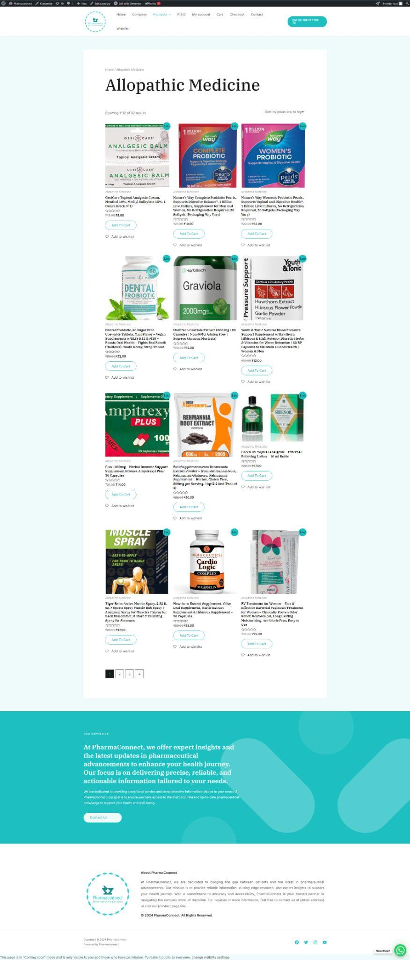

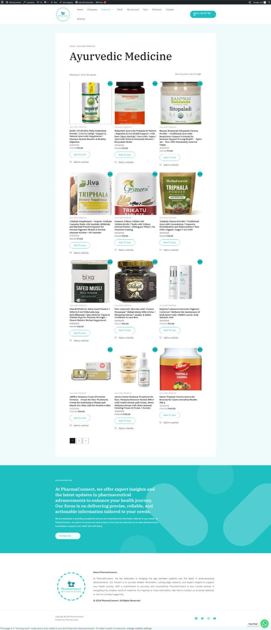

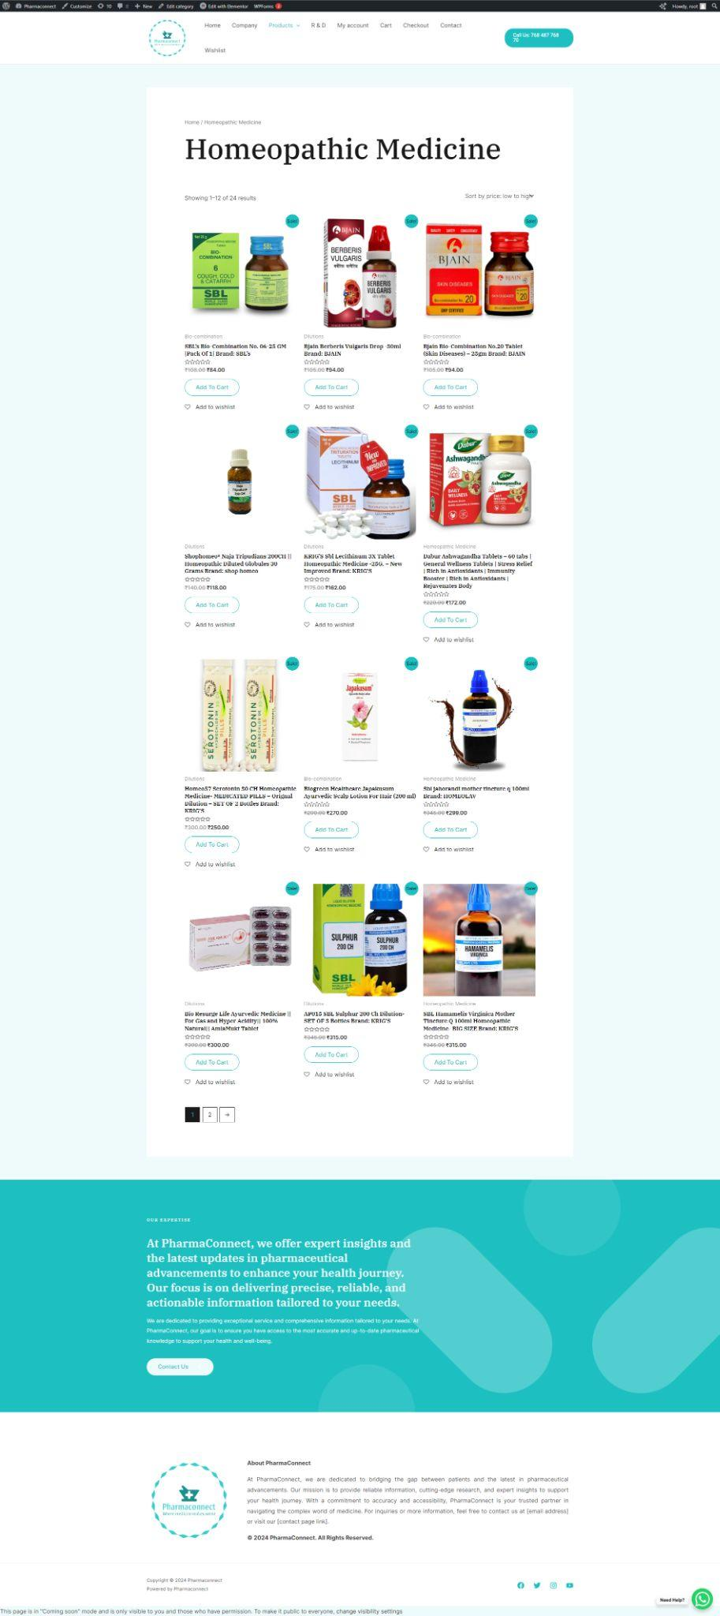

**Contect us:-**

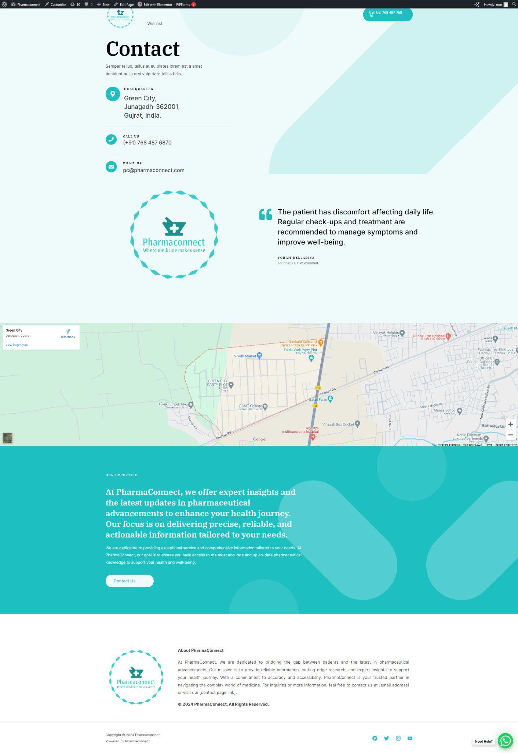

**Add To Cart:-**

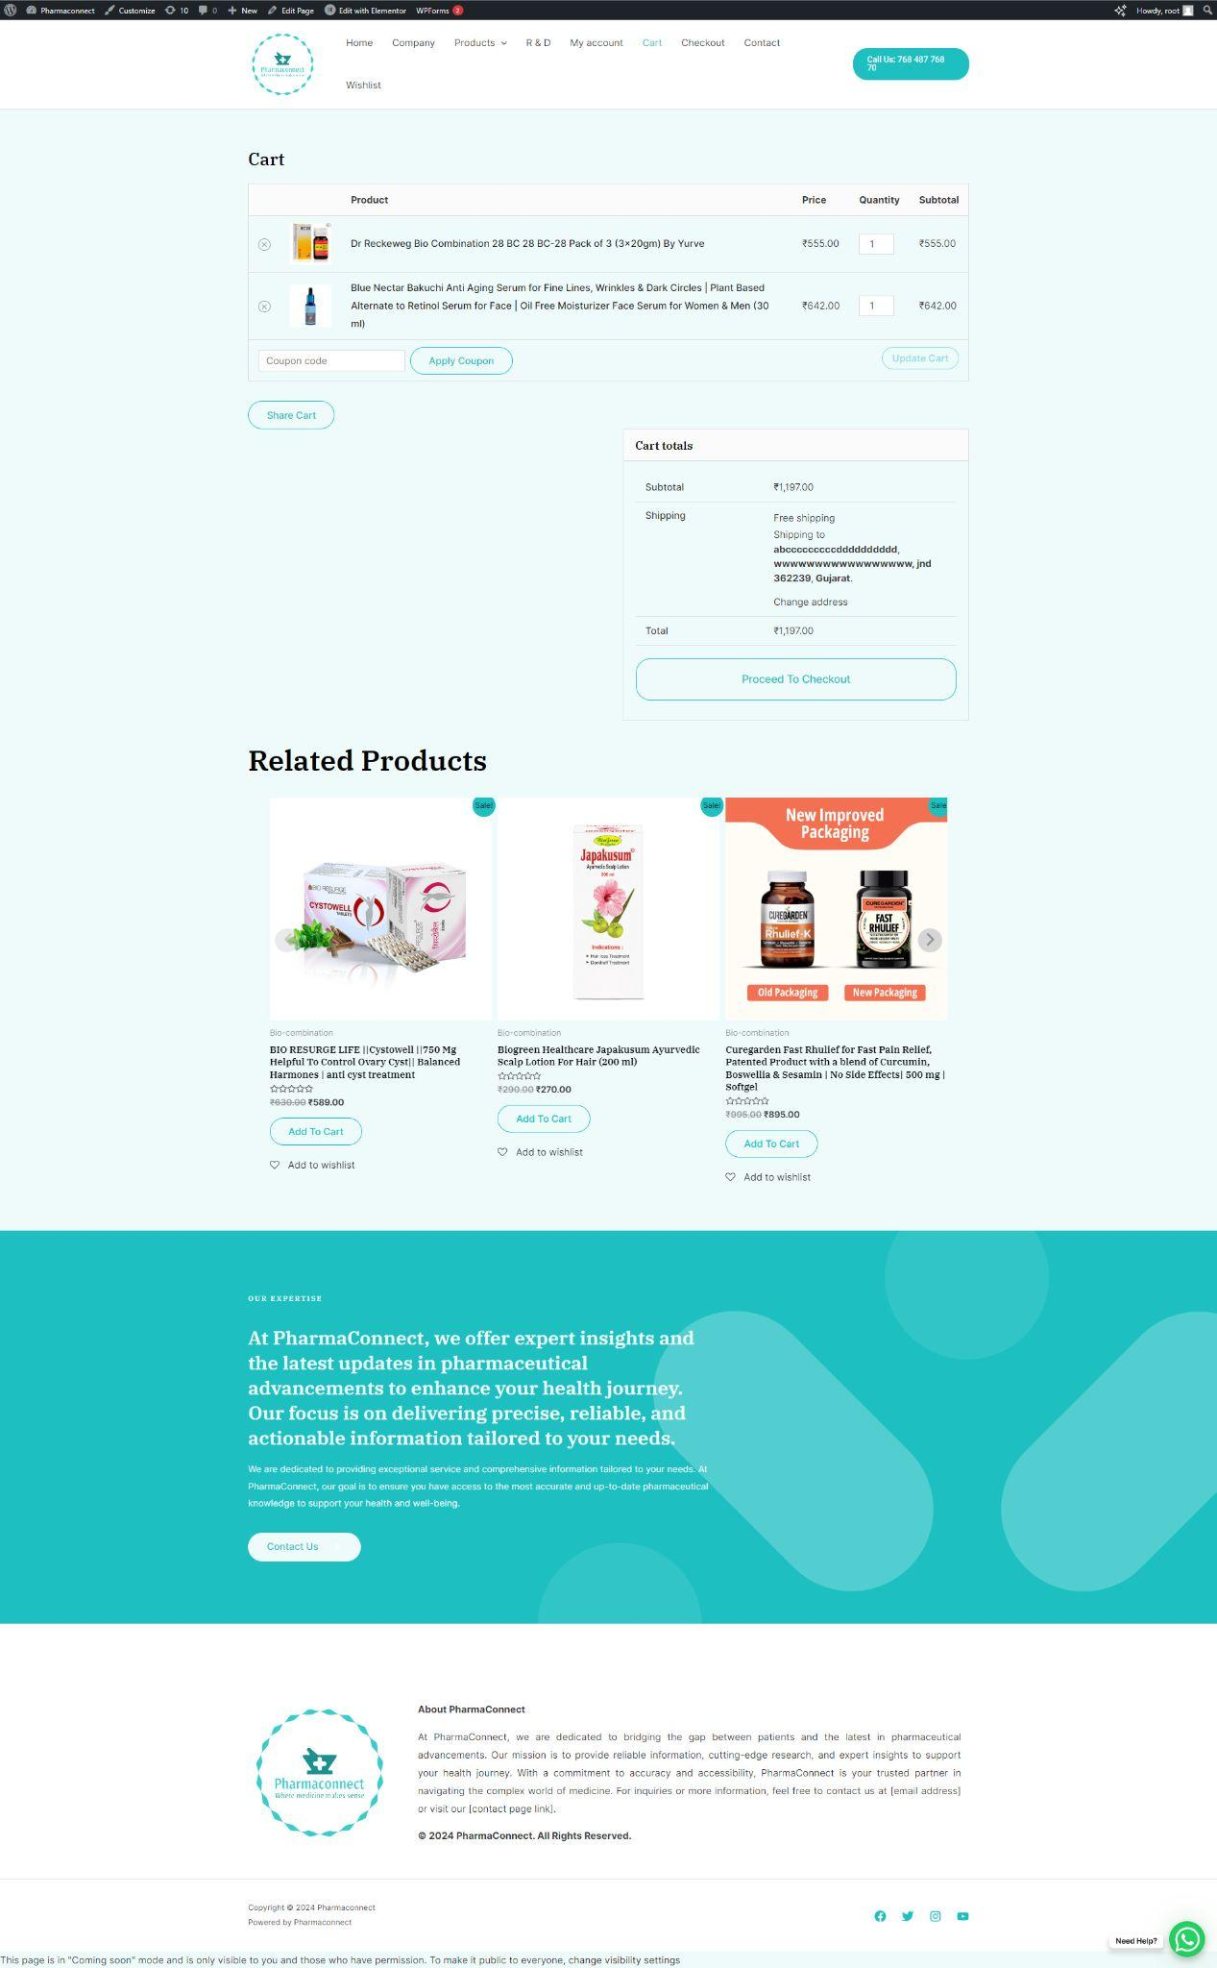

**Process checkout:-**

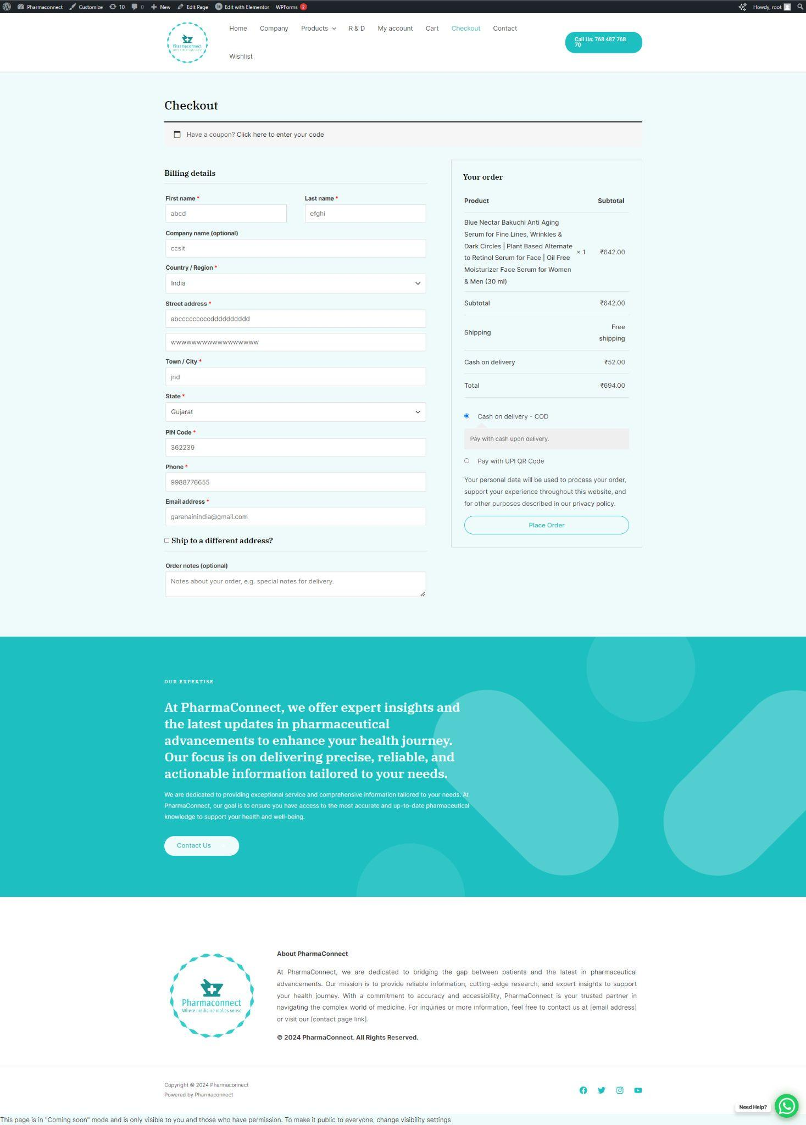

#### Order Bill:-

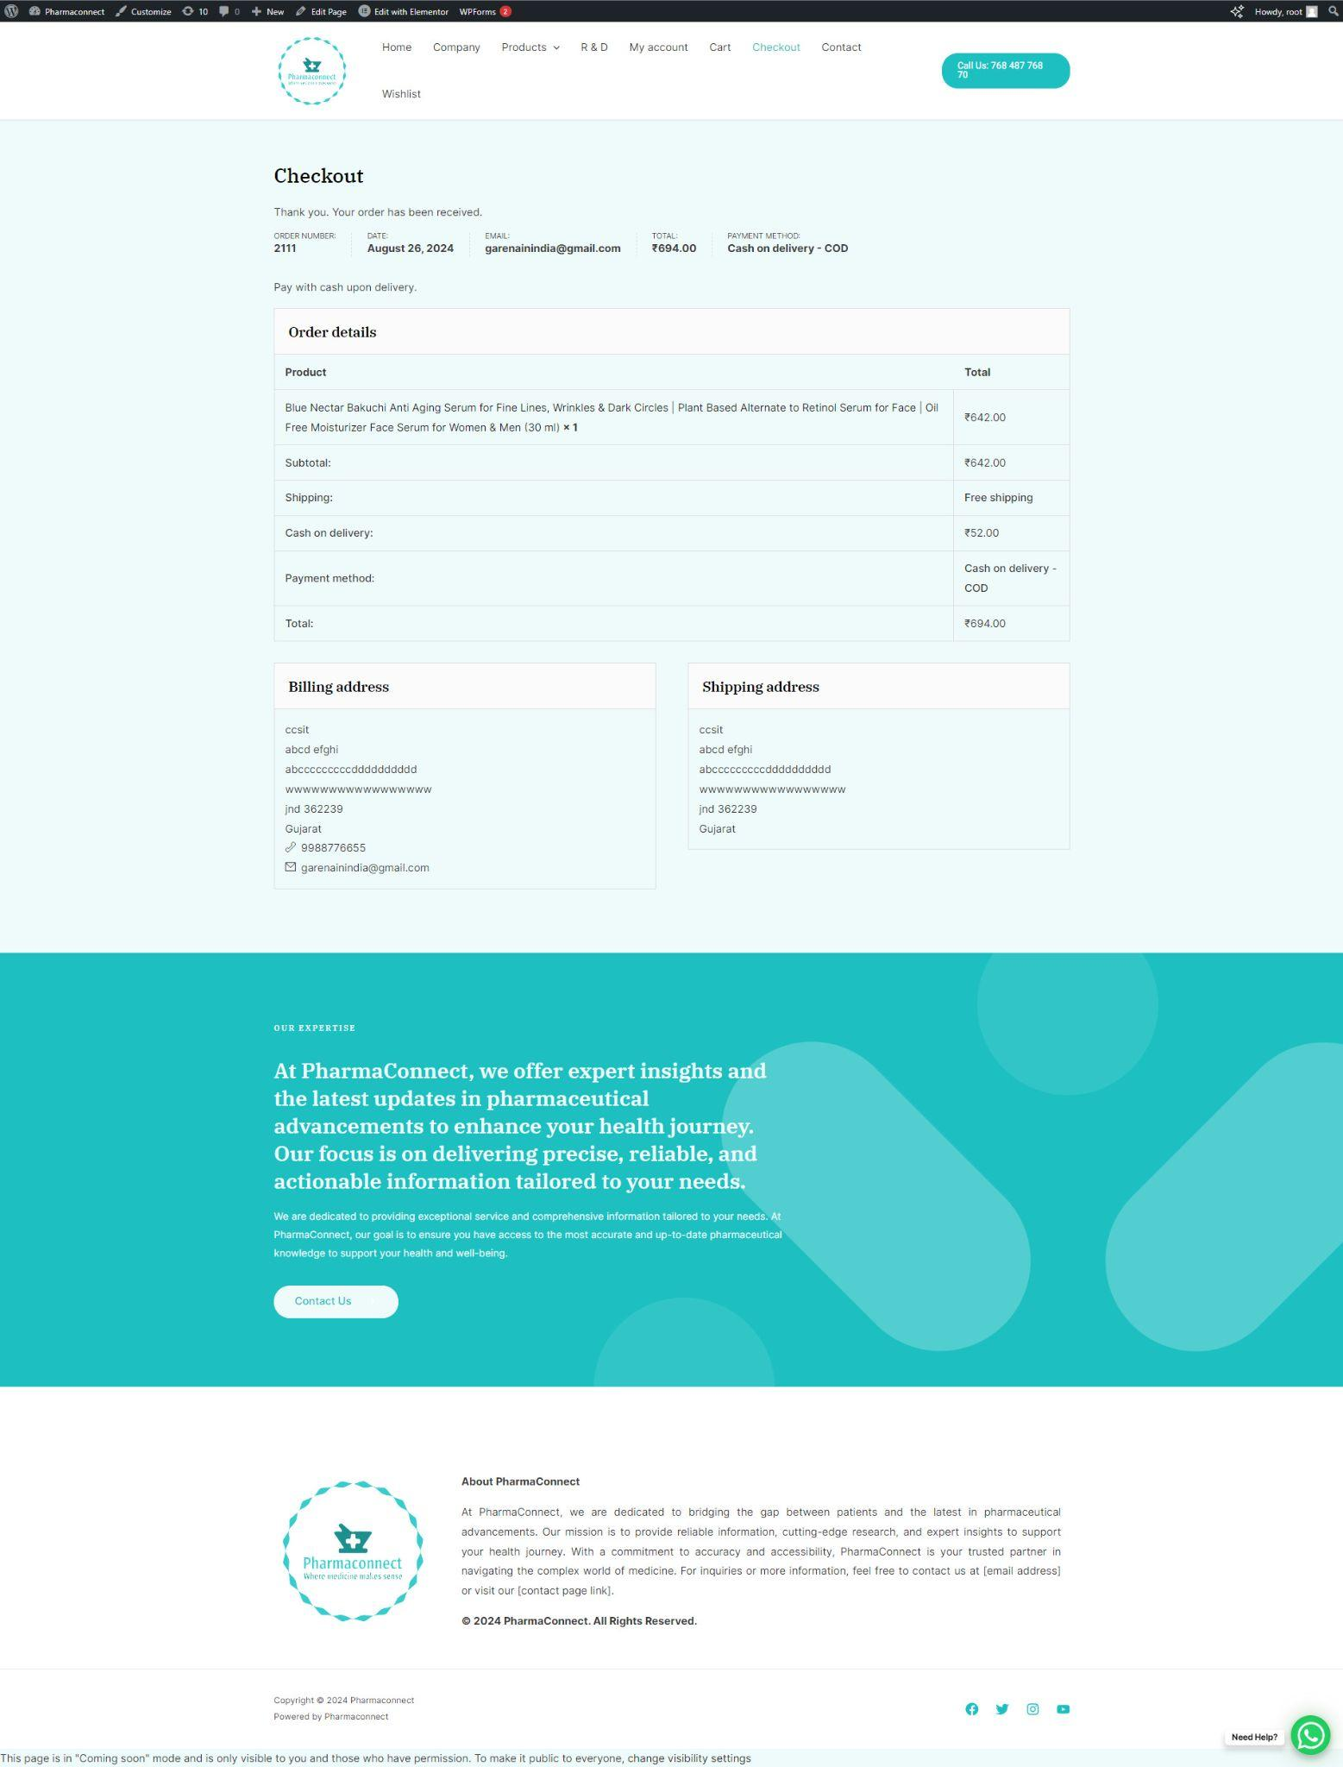

**Admin:-**

**Login Window:-**

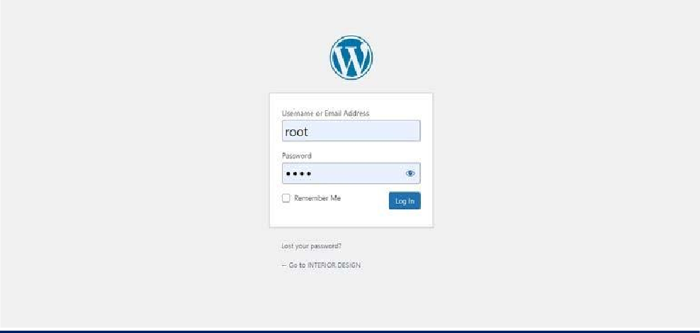

**Pages:-**

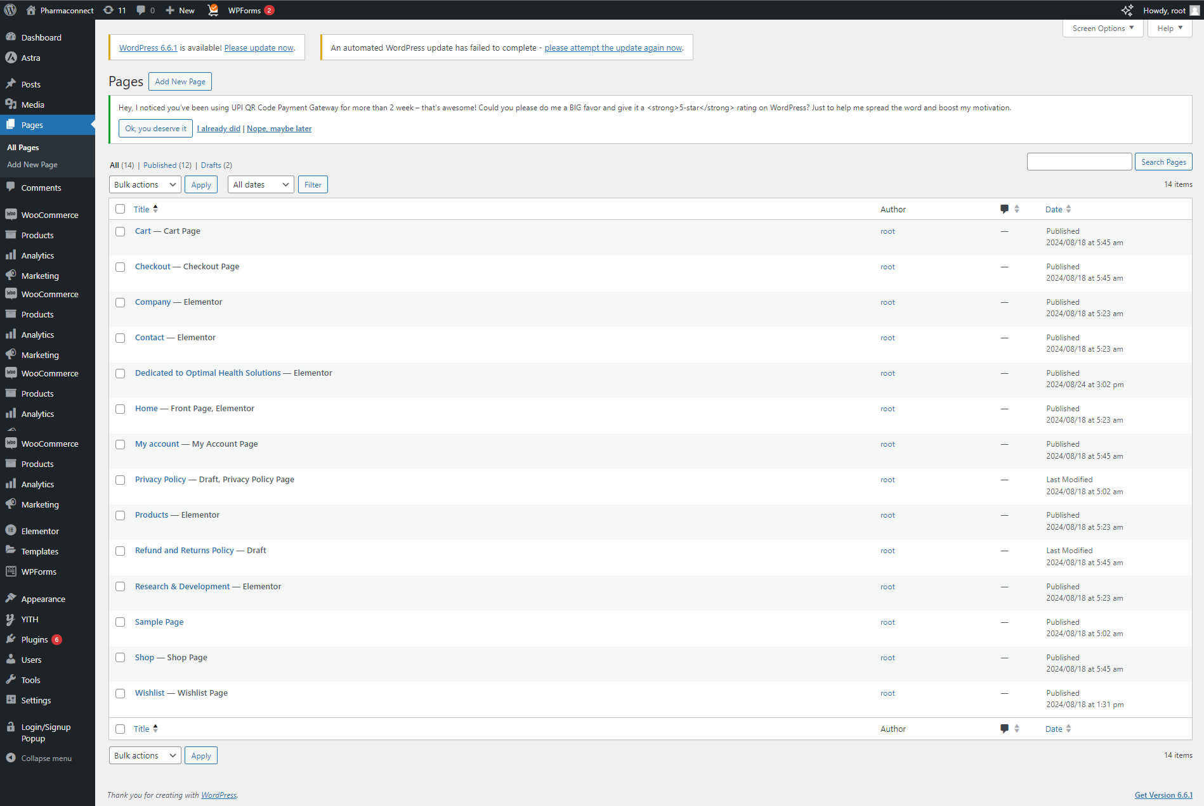

**Categories:-**

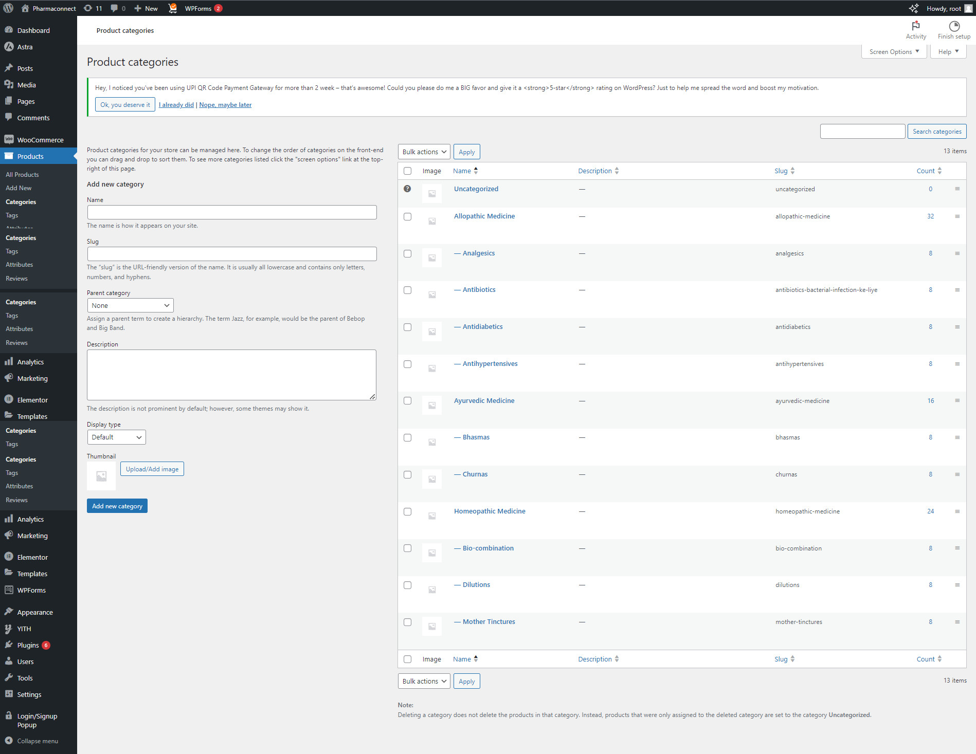

**Order:-**

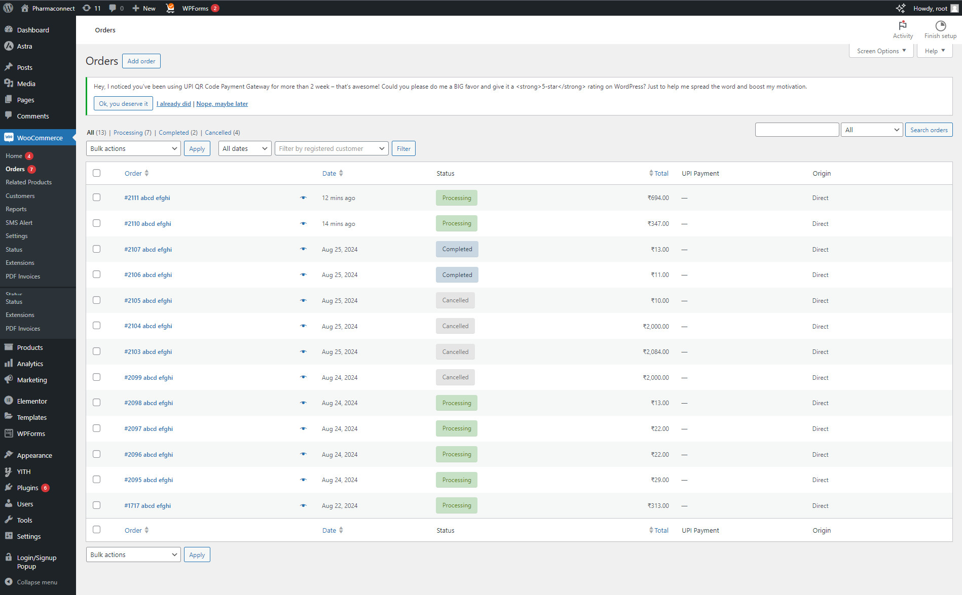

# CHAPTER 9 SYSTEM DEVELOPMENT



## Plugin

#### WooCommerce :-

WooCommerce is a free eCommerce plugin that allows you to sell anything, beautifully. Built to integrate seamlessly with WordPress, WooCommerce is the world’s favorite eCommerce solution that gives both store owners and developers complete control.

With endless flexibility and access to hundreds of free and premium WordPress extensions, WooCommerce now powers 30% of all online stores — more than any other platform.

##### LOGIN/SIGNUP POPUP (INLINE FORM + WOOCOMMERCE) :-

A simple and lightweight plugin which makes registration, login & reset password process super smooth. You get two awesome fully customizable designs – Popup & Inline form with shortcodes. You can choose which field to keep from the fields manager.

#### Force Authentication Before Checkout for WOOCOMMERCE:

Force customer to log in or register before checkout to increase your conversion rate.

##### WOOCOMMERCE SMART COD: -

This plugin extends WooCommerce Cash on Delivery Gateway, providing the capability to add not one, but multiple different extra fees and restrictions based on customer’s location, selected shipping method and many other factors.

##### UPI QR CODE PAYMENT GATEWAY FOR WOOCOMMERCE : -

This Plugin enables WooCommerce shop owners to get direct and instant payments through UPI apps like BHIM, GooglePay, WhatsApp, Paytm, PhonePay or any

banking UPI app to save payment gateway charges in India. UPI (Unified Payments Interface) is a payment standard owned by National Payment Corporation of India, a government owned instant payment solution. UPI works 24×7 and is free subject to prevalent government guidelines.

##### SIMPLE CHAT BUTTON: -

Simple Chat Button is the Fastest (No use JavaScript), Lightweight and Very Simple WordPress plugin that displays the beautiful WhatsApp Sticky Button on the WordPress frontend. After clicking on the WhatsApp Sticky Button, it will bring you to the WhatsApp application.

##### MC WOOCOMMERCE WISHLIST : -

Wishlist is an eCommerce feature that enables shoppers to create and save a list of appliances they wish to buy at a later point in time. This is similar to bookmarking your favorite websites to easily visit them when needed. Customers can save their valuable time by adding their desired appliances to the wishlist and purchasing them at a later time.

##### SMS ALERT ORDER NOTIFICATIONS: -

This is a WooCommerce add-on. By Using this plugin admin and buyer can get notification about their order via SMS using SMS Alert.

The WooCommerce Order SMS Notification plugin for WordPress is very useful, when you want to get notified via SMS after placing an order. Buyer and seller both can get SMS notification after an order is placed. SMS notification options can be customized in the admin panel very easily.

##### PDF INVOICES & PACKING SLIPS FOR WOOCOMMERCE : -

This WooCommerce extension automatically adds a PDF or UBL invoice to the order confirmation emails sent out to your customers. Includes a basic template as well as the possibility to modify/create your own templates. In addition, you can choose to download or print invoices and packing slips from the WooCommerce order admin.

##### MYSTICKYMENU :-

Use My Sticky Bar to create a beautiful notification bar for your website. You can also use this notification bar & sticky menu plugin to make your menu or header sticky on top of page, after desired number of pixels when scrolled.

## Error Detection & Solution

* + - **Website Error:** Failed to start application: Could not connect to MySQL server.

**Solution:**Start MySqlFrom XAMPP.

* + - **Product Add Error :**An element with the same alias already exists

**Solution:**Product Already Exists. Try With New Name.

# CHAPTER 10

# TESTING & QUALITY ASSURANCE



#### Types of Testing & QA

* + - **Introduction : -**
      * Testing is a process of executing a program with the indent of finding an error.
      * Testing is a Crucial element of software quality assurance and presents ultimate review of specification, design and coding.
      * System testing is an important phase.
      * Testing represents an interesting anomaly for the software, thus a series of testing are performed for the proposed system before the system is ready for user acceptance testing.
      * A good test case is one that a high probability of finding an as undiscovered error.
      * A Successful test is one that uncovers an as undiscovered error.

There are various types of testing techniques are describes as follows.

☺ ***Unit Testing:-***

🡺 Here in this project we test each and every form and connection class of software application individually when it is completely coded.

🡺 A unit is the smallest testable part of an application benefits.

🡺 The goal of unit testing to isolate each part of the program and show that the individual part are correct a unit test provides a strict written contract that the piece of code must satisfy.

🡺 There are some methods for unit testing are as follows.

☺ ***Black-Box Testing:-***



#### Black box Diagram

🡺 Black-box testing is a method of software testing

🡺 Typical black-box test design techniques include**:**

* + - * + Decision table testing
        + All pairs testing
        + State transition table
        + Equivalence partitioning
        + Boundary value analysis

☺ ***White-Box Testing:-***

White-box testing also known as clear-box testing, glass-box testing, transparent –box testing and structural testing is a method of testing software

White-box test design techniques include:

* Control flow testing
* Data flow testing
* Branch testing
* Path testing

## 10.2 Test Case Design

#### Feedback

| **Test Case ID :** Feedback | **Test Designed by :** Delvadiya Foram |
| --- | --- |
| **Test Priority(Low/Medium/High) :** Med | **Test Designed date :** 15/8/2024 |
| **Module Name :** Feedback | **Test Executed by :** Delvadiya Foram |
| **Test Title :** Verify Feedback | **Test Execution date :** 20/8/2024 |
| **Description :** Test the Feedback page |  |
| **Pre-conditions :** User can give feedback. | |

**Test data Table : Feedback**

| **Field Name** | **Validation** | **Test Data** | **Result** |
| --- | --- | --- | --- |
| **Email** | Required | 1)"null" | Email field is Required. |
| Email | 2)a@.com | Email must be a valid email address. |
| 3) [ForamD@gmail.com](mailto:ForamD@gmail.com) | Valid |
| **Your Review** | Required | 1)"null" | Message field is Required. |
|  | 2)Good Information of Home Decorations Items. | Valid |

**Post-Conditions :** User is gives valid Feedback.

# CHAPTER 11 FEATURE ENHANCEMENT



* + We can update this system as online application.
  + We can provide multi languages.
  + We can provide GUI.
  + Users can view the Medical Product of different - different Types like Ayurveda Medicines, Allopathic Medicines Etc.

# CHAPTER 12 BIBLIOGRAPHY



* **WEB REFERENCES:-**
  + [www.google.com](http://www.google.com/)
  + [www.en.wikipedia.org](http://www.en.wikipedia.org/)
  + [www.wordpress.com](http://www.wordpress.com/)
  + [www.medicinshop.](http://www.medicinshop./)com
  + [www.pharmeasy.com](http://www.pharmeasy.com/)
  + [www.truemeds.com](http://www.truemeds.com/)

# CCHAPTER 13 CONCLUSION



PharmaConnect, user-friendly Online Shopping Website in which beautiful design intersects with a rich variety of Medical Products for Attractive. High- resolution product, step-by-step category, personal experience by making it easily accessible and providing a online Medical items for users.